**Changing the port:**

edit the nexus.properties file inside conf folder under nexus home directory as below



Then restart nexus and add security group for EC2

**Changing default storage location:**

* We can also change the default storage location of nexus as below
* Go to **NEXUS_HOME/conf** and edit **“nexus.properties”** and modify **“nexus-work”** path as below.

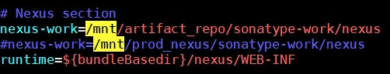

* By default, it used to be inside **NEXUS_HOME/sonatype-work/storage**
* As above also, it would create one **“storage”** folder inside the given path and then created sub directories with the repo names as below.

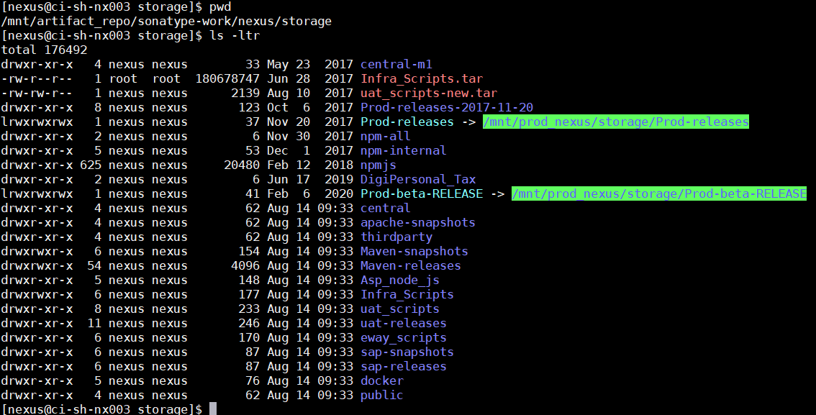

* Inside those sub directories, nexus copies the artifacts in same folder structure as we have in .m2 repo.

**Copying the artifacts directly to nexus storage location:**

* We can simple create the folder structure as we want inside the storage folder of nexus default location
* And copy paste the artifacts as below

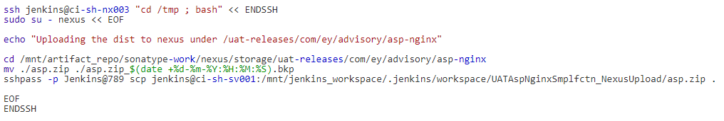

* Once after this, we can also view the artifacts from UI as well.